Thank you to Wholesale Club for their generous support of food banks across Canada!

Wholesale Club has 56 locations across Canada and carries a wide variety of perishable and non-perishable retail and club size products, with access to all Loblaw listings upon request.
For more information on purchasing, please see the Wholesale Club tile on Marketplace.

Wholesale Club – Food Bank Savings Program includes:

We are pleased to offer a Bulk Gift Card Program that provides eligible companies
and community groups cost saving incentives.

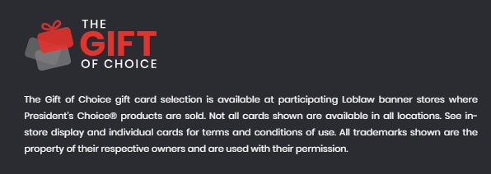
Bulk Gift Card Program – Click here to visit the website
2% discount on gift card purchases between $2,000 - $4,999 3% discount on gift card purchases between $5,000 - $9,999 4% discount on gift card purchases between $10,000 - $19,999 5% discount on gift card purchases over $20,000**

**Limit of $500,000 per authorized charitable organization per year.

Locations: Wholesale Club has 56 locations across Canada. Click here to see their location list

Questions? Please reach out to your local Wholesale Club store via e-mail

Steps to receive Food Bank Savings Program discounts:

Not a Wholesale Club Member? To receive your Wholesale Club Gold Card membership and access gift cards, submit your Wholesale Club application to:

Email: himani.taneja@loblaw.ca and cc: marketplace@foodbankscanada.ca
Include in email subject line: “Food Bank Gold Card and Loyalty Program Registration”

For other information and Marketplace inquiries, please contact:
Marketplace Manager at Food Banks Canada
Email: marketplace@foodbankscanada.ca

