Thank you to Perrigo for their generous support of food banks across Canada!

Food bank prices are listed at the end of this document.

*Prices are for direct delivery only. Prices are subject to change. Pricing is confidential. National pricing in effect.

Delivery available in:
- All provinces
- None of the territories (unless product can be delivered to a port or airport to co-ordinate with a shipment leaving to any territory location)

Delivery charge: No charge if minimum order is achieved.

Minimum Order: 20 cases OR $500
- Only full cases of any given item can be ordered – no partials

Order lead time: One – two weeks (depending upon location) + shipping

Order method: Email preferred, but can also accept fax orders

Payment methods accepted: Cheque or EFT

Steps to start purchasing from Perrigo (Good Start):

Step 1. If you are interested in purchasing and would like to set up an account for Good Start Formulas, complete the Shandex credit application and submit to credit@shandex.com (please, copy supplier@mavericksales.com). Upon receipt of this document, Shandex will set up a new customer account for you. This process takes approx. 10 business days.

Step 2. Submit your completed order form to customer-service@shandex.com (please, copy supplier@mavericksales.com) for Good Start formulas for processing.
For any questions relating to delivery time frames, payments received, etc., please direct them to arsdx@shandex.com.

For any additional information about Good Start baby formulas and prices, please contact:
Matthew Bosco, Maverick Sales
Email : supplier@mavericksales.com or matt.bosco@mavericksales.com
Mobile: 905-749-3994

Good Start Pricing per SKU:

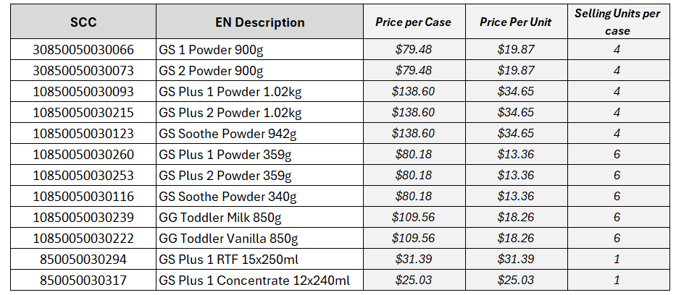

*Prices are for direct delivery only. Prices are subject to change. Pricing is confidential. National pricing in effect.

For other information and inquiries on Marketplace, please contact:

Marketplace Manager at Food Banks Canada
Email: marketplace@foodbankscanada.ca

