Food Banks Canada would like to thank Nature’s Path Foods
for their generous support of food banks across Canada.

For over thirty years, Nature’s Path has been a pioneer in the organic food movement. We are a Canadian family-owned company founded in 1985. It is our mission to provide families with nourishing organic foods while leaving the earth better than we found it. At Nature’s Path we believe every time you choose organic, you cast a vote for a better food system and a more sustainable future for us all. All Nature’s Path products are organic and non-GMO and we are a Zero-Waste Certified company.

Website URL: https://naturespath.com/en-ca

Item Examples | Price Examples*
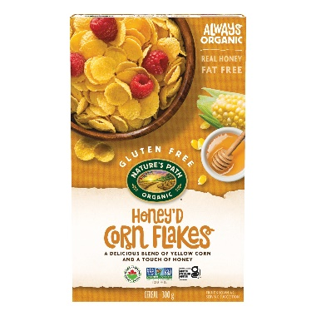  Nature's Path Organic Honey'D Corn Flakes Cereal 300g Box | $30/case $2.50 unit vs $5.99 retail
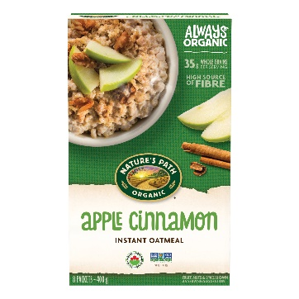  Nature's Path Organic Apple Cinnamon Oatmeal  400g Box sachet | $20/case $3.33 unit vs $6.49 retail
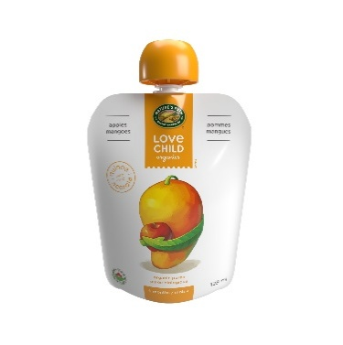  Love Child Organics Superblends Apple + Mangoes Puree  128ml Pouch | $16/case $1.33 unit vs $2.49 retail

Direct Delivery to Food Banks available:
No, Food bank to arrange for pick-up of product
FOB Richmond, BC or Vaughan, ON

Minimum Order:
3 pallets mix & match

Order Lead Time:
7 days

Order method:
Contact Name: Kerri Job
Phone: 604-365-7505
Email: kjob@naturespath.com

Payment Method Accepted and Terms:
Wire Transfer preferred or cheque if wire unavailable

Process to submit Customer/Credit application:
Contact Name: Jezebel Astudillo
Email: jastudillo@naturespath.com

Contact information:
Customer Service Manager, Lea Howard
Email: lhoward@naturespath.com

For other information and inquiries, please contact:
Marketplace Manager at Food Banks Canada
Email: marketplace@foodbankscanada.ca

