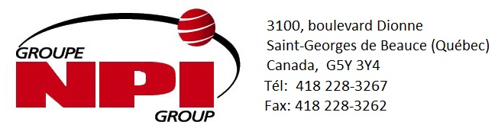

CREDIT APPLICATION

|  |
| --- |
| Legal name of the company: |
| Address:  Delivery address: (if different)  Delivery informations required:  Tailgate  Appointment required  Straight Truck  53ft trailer  Please tell us your receiving hours:  Other requirements:  Nature of the business :  # year in business :  GST / QST number |
| City :  Postal code : |
| Phone number : |
| Fax number : |
| E-mail address of the buyer :  E-mail adress for promotion /deal : |

Financial information

|  |
| --- |
| Financial institution:  Account manager:  Credit limit requested:  Transit number:  Institution number :  Account number : |
| Address of the bank:  Phone number:  Fax number : |
| Contact : |
| Trade references: (4)  Name: Name:  Address: Address:  Phone number: Phone number:  Contact:  Contact :  Name : Name :  Address : Address :  Phone number : Phone number :  Contact :  Contact : |
| General information |
| Account payable contact :  E-mail adress : |
| Buyer name:  E-mail adress : |
| Credit limit requested : |
| Invoices sent by :  E-mail :  Mail :  Would you like an account statement ?  Yes or No  By :  Fax :  Email :  Mail : |

**The owners, the partners and the shareholders**

|  |  |  |
| --- | --- | --- |
| Name : | Address : | Phone Number |
|  |  |  |
|  |  |  |
|  |  |  |

**Business Agreement**

Between _______________________________(buyer/name of the company)

and **Groupe NPI ( vendor)**

Signed at : ______________________________

Date : _________________________________

* Please send it to: [comptabilite@nikolpoulin.com](mailto:comptabilite@nikolpoulin.com) and we will get back to you shortly ! Thank you !